Date: __________________ Scout Name: ________________________
Scout Inspector: _______________________ Adult Inpsector: ______________________
Name | Notes and Tips | Priority | Check If Present
Tent (3 or 4 season) | A “4 season” tent is recommended, but not required. See below for how you can enhance the cold weather abilities of your 3 season tent if desired. | REQUIRED
Large Tarp | In cold weather, stake down a tarp over your tent to improve insulation and also significantly improve its ability to block wind and rain. Especially recommended if you are using a 3-season tent (most tents, including troop tents). Try a plow point tarp setup with a tree, use a ridgeline with two trees, or use a tarp pole or treking pole (see “closed-end A-Frame). Pro Tip: stake the tarp ALL THE WAY to the ground to prevent wind from sweeping underneath and into your tent. | Recommended
Extra Tent Stakes and Guylines | Extra stakes and guylines are needed to secure your tent in bad weather as well as enhance insulation and protection with a tarp. | Recommended
Moving Quilt | This can be obtained at low cost from Harber Freight. Helps create extra insulation on the bottom of the tent from the snowpack underneath. | Optional
Tentmate | At least one tentmate (same gender not more than two years apart) must be confirmed. | REQUIRED
Nalgene or Equivalent | Shoult be at least 32 oz. Two are preferable. Can also be used as a bag warmer when filled with boiling water. Note: Hot bottle can burn you. Bring a slip or cover for it to reduce this risk. | REQUIRED
Cold-Weather Sleeping Bag | Needs to be at least 0 degree bag. Multiple bags together can substitute. | REQUIRED
Sleeping Pad | Can substitute with foam or reflectix. However, highest R-Value possible is best (5.5 or higher preferred). | REQUIRED
Flashlight or head-lamp | Not beging able to see is especially harzardous in cold conditions. | REQUIRED
Sleeping Bag Liner | Most of these will add 10 degrees to the bag. Specialty liners can add more, but assume 10 unless otherwise labeled. | Optional
Pillow |  | Recommended
Tent Footprint / Ground Cloth | Snow can melt underneath your tent. This can help prevent moisture from seaping through. | Highly Recommended
Heavy down or synthetic jacket | This is primary upper body insulation layer. “Puffy jackets work well as do sweaters in fleece or wool. | REQUIRED
Wind/Rain Proof Jacket | Should be rain and windproof. Should be big enough to layer underneath | REQUIRED
Wind/Rain Proof Pants (or additional pair of pants) | Should be rain and windproof. Should be big enough to layer underneath. An extra pair of pants or two may substitute if rain proof pants are not available. | REQUIRED
Lower pant insulation (midlayer) | This layer can be built into the outer shell (as with ski pants). No cotton. | REQUIRED
Baselayer Shirt | Should be moisture wicking and fit close to the body. Should be long sleeve. | REQUIRED
Baselayer Pant | Should be moisture wicking and fit close to the body. Should be long sleeve. | REQUIRED
Insulated Gloves or Mittens | Should be water resistent and wind resistent. | REQUIRED
Liner Gloves | This fit inside insulated gloves to allow insulated gloves to be removed for more dexterety. Also improved insulation. | Recommended
Cold Weather Beanie | Should be worn while sleeping as well as daytime activities. The thicker the better. | REQUIRED
Briefs or Underwear | Wear moisture wicking briefs (underwear). Change into clean briefs at night. Bring multiple pairs. Try to avoid cotton. | REQUIRED
Long Underwear | Should be worn only when sleeping. Should be a heavy material for insulation. | REQUIRED
Warm Socks | Should be wool or synthetic insulated material (no cotton). At least 4-5 pairs recommended. Fresh socks should be worn at night. Down socks/booties for sleeping will upgrade significantly for a common problem area. | REQUIRED
Sun Glasses/Goggles | Reflexion from snow can be blinding. Glasses also protect the eyes from wind and rain. | REQUIRED
Gaiters | Assist with keeping lower legs dry. | Optional
Winter Boots | Should be waterproof and insulated. | Recommended
Balaclava and/or Neck Gaiter | The face is often forgotten. A face cover will protect from biting wind and rain. A neck gaiter or balaclava will protect the face as well as the neck. This item becomes more necessary as the temperature drops. | REQUIRED
Hand Warmers | Chemically activated. These can become very helpful if hands become very cold and hard to warm up. Usually lasts a couple of hours so have several in your pack. | Recommended
Toe Warmers | Chemically activated. These can become very helpful if toes become very cold and hard to warm up. Usually lasts a couple of hours so have several in your pack. | Recommended

Learn More About The Below Guide On Clothing By Watching This Video:
https://www.youtube.com/watch?v=uVQ0KcHjZrY
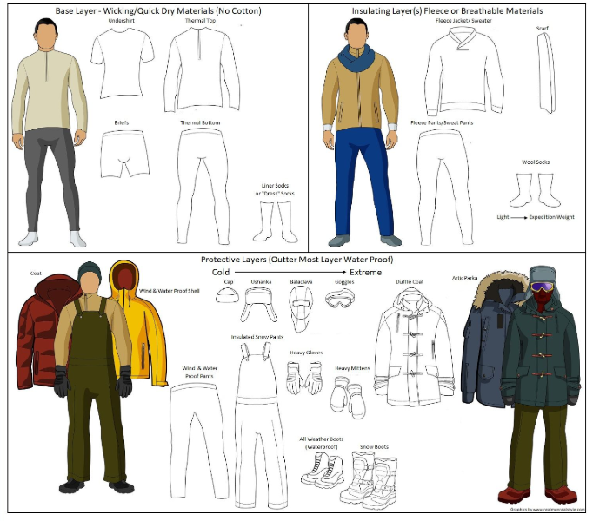

Winter Camping Tips:

Staying Warm While Sleeping
Change into a new set of dry clothing before going to bed. Double up sleeping bags to improve temperature rating. Use a thick sleeping pad, cardboard, foam or other ground barriers (or improvise a thick pad with blankets or another sleeping bag). Sleep with a stocking cap and thick socks. Sleep 2 or 3 or more to a tent. Wake up your buddy if you are shivering and cold. Get help from a leader if you can’t get warm. Be careful with (or avoid) hand warmers in sleeping bags while sleeping as they can cause burns. Do some sit-ups or pushups before climbing in your bag to help you warm it up. Follow the buddy system; camp at night can be very disorienting – don’t get lost alone in the cold!

Staying Warm During Activity Time
Wear layers!
Do not wear your sleeping clothes, change your clothes when you get up.
Stay hydrated. You may not feel thirsty in the cold, but it’s important to drink fluids.
Try not to sweat. If you are working, add/remove layers or take breaks as needed to avoid overheating.
Pay close attention to toes, fingers, and ears for signs of frostbite.
Waterproof shoes can cause a buildup of moisture in the shoe. You may need to change socks during the day to keep your feet dry and warm so bring extra. Breathable shoes may perform better than waterproof in dry conditions.
Avoid fibers that hold moisture (Cotton). Take breaks to warm up in a tent or shelter. Use the buddy system and look out for each other.

