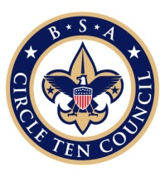 | CIRCLE TEN COUNCIL  EAGLE SCOUT APPLICATION INFORMATION  (must be submitted with application)  NOTE: EAGLE CERTIFICATES WILL BE RETURNED AND PICKED UP ONLY WHERE THEY WERE ORIGINALLY SUBMITTED!  Please circle one:  Murchison Scouting Center Bobby Lyle/Billy Gamble Scouting Center  Dallas TX Fairview TX

Chartered
UNIT #: (Troop, Team, Crew, Ship) Organization:

District: Board of Review Date:

Scout’s Name:

Unit Contact: Home Number:
Work or Cell #: Contact email address:

(You will be notified via email when the Eagle packet returns from national.)

DO NOT SCHEDULE THE COURT OF HONOR UNTIL THE EAGLE PACKET HAS BEEN RETURNED TO CIRCLE TEN COUNCIL AND YOU ARE NOTIFIED TO ENSURE YOU HAVE THE CERTIFICATE AND KIT FOR THE COURT OF HONOR.

COUNCIL USE ONLY

Received by: Checked by: Date:

Information sheet
emailed to Dallas: Processed by: Date:

Application delivered to Dallas: Scanned to Nat’l: Date:

Certificate received from Dallas: PID #:

Contact Notified by: Date: Date given to Scout Shop:

SCOUT SHOP USE ONLY
Date: Eagle picked up by:
(Signature)

Please print name:

